**I2C MODULE FOR 16X2 (1602) CHARACTER LCD**

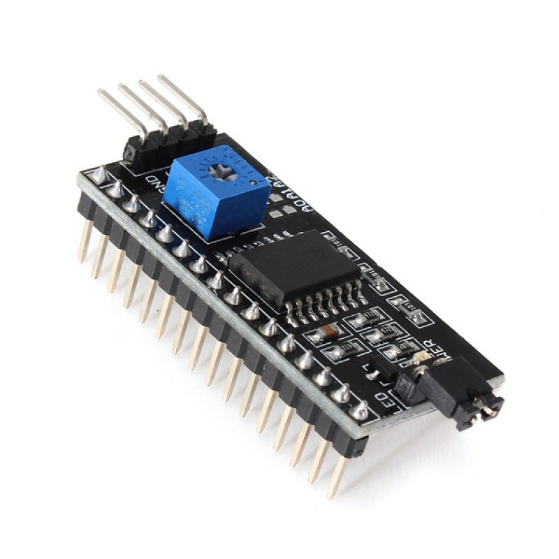

**Description:-**

I2C Module has a inbuilt PCF8574 I2C chip that converts I2C serial data to parallel data for the LCD display.

These modules are currently supplied with a default I2C address of either 0x27 or 0x3F. To determine which version you have check the black I2C adaptor board on the underside of the module. If there a 3 sets of pads labelled A0, A1, & A2 then the default address will be 0x3F. If there are no pads the default address will be 0x27.

The module has a contrast adjustment pot on the underside of the display. This may require adjusting for the screen to display text correctly.

**Features:-**

* Operating Voltage: 5V
* Backlight and Contrast is adjusted by potentiometer
* Serial I2C control of LCD display using PCF8574
* Come with 2 IIC interface, which can be connected by Dupont Line or IIC dedicated cable
* Compatible for 16x2 LCD
* This is another great IIC/I2C/TWI/SPI Serial Interface
* With this I2C interface module, you will be able to realize data display via only 2 wires.